
RAMAIAH
Institute of Technology
USN | 1 | M | S

(Autonomous Institute, Affiliated to VTU)
(Approved by AICTE, New Delhi & Govt. of Karnataka) Accredited by NBA & NAAC with ‘A’ Grade

SEMESTER END EXAMINATIONS FEBRUARY – MARCH 2021
Program | : | B.E. : Computer Science and Engineering | Semester | : | III
Course Name | : | Theory of Computation | Max. Marks | : | 100
Course Code | : | CS34 | Duration | : | 3 Hrs

Instructions to the Candidates:
- Answer one full question from each unit.

 |  | UNIT- I
1. | a) | Define DFA. Design a DFA to accept the language containing strings that ends with b but does not contain the string aa. Give the moves made by the DFA on the string abbab. | CO2 | (08)
 | b) | Prove that a language L is accepted by some ε-NFA if and only if L is accepted by some DFA. | CO4 | (05)
 | c) | Consider the following ε-NFA. Find the ε-closure of each state and convert it to an equivalent DFA. | CO3 | (07)
  State | δ
  State | a | b | ε
  →q₀ | q₂ | Ф | {q₁}
  q₁ | {q_{3 ,}q₄} | Ф | Ф
  * q₂ | Ф | {q₄} | {q₂}
  q₃ | {q₄} | {q₄} | Ф
  q₄ | Ф | Ф | Ф
2. | a) | Define:  (i) Language (ii) String (iii) Alphabet (iv) Power of an alphabet. | CO1 | (04)
 | b) | Design a DFA to accept the strings containing either ab or bba. Show the moves made by the DFA on the string ababba. | CO2 | (08)
 | c) | Convert the following NFA into an equivalent DFA using lazy evaluation method. | CO3 | (08)
  State | δ
  State | 0 | 1
  →q₀ | {q₀} | {q₁,q₂}
  q₁ | {q₁,q₂} | {q₂}
  * q₂ | {q0,q1} | {q₁}
 |  | UNIT – II
3. | a) | Obtain the regular expressions to describe the following languages.  - Set of strings over {0,1} with at most one occurrence of 11.  - L= {a^{m}b^{n} , m+n is even}  - Strings of 0’s and 1’s whose lengths are multiples of 3. | CO2 | (06)
 | b) | Prove that every language defined by a regular expression is also defined by a finite automaton. | CO4 | (07)
 | c) | Convert the following into a regular expression by eliminating states.  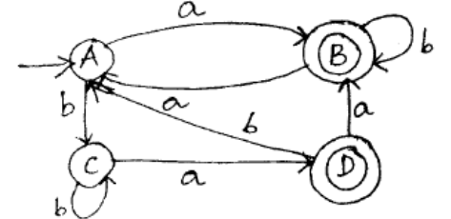 | CO3 | (07)
4. | a) | Prove that regular languages are closed under union, complementation and difference operations. | CO4 | (06)
 | b) | State the pumping lemma for regular languages. Prove that the set of strings of 0’s and 1’s of the form ww is not a regular language. | CO4 | (05)
 | c) | Minimize the DFA given below.  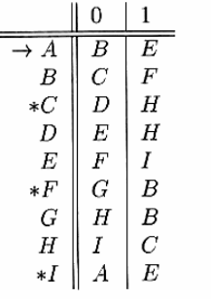 | CO3 | (09)
 |  | UNIT – III
5. | a) | Define context free grammar. Define CFG for the following:  - Binary strings with twice as many ones as zeros.  - L={a^{n}b^{m}| n≠m} | CO1 | (07)
 | b) | Define ambiguous grammar. Verify whether the grammar  S → aB / bA, S → aS / bAA / a, B → bS / aBB / b, is ambiguous? | CO3 | (05)
 | c) | Prove that if there is a PDA P_{N} which accepts strings from a language L by empty stack, then there also exists a PDA P_{F} that accepts L by final state. | CO2 | (08)
6. | a) | Consider the following grammar:  SABC, AaA, Aε, BbB, Bε, CcC, Cε. Give the leftmost derivation, rightmost derivation and the parse tree for the string aabbba. | CO3 | (06)
 | b) | Design a PDA for accepting a language {a^{n}b^{2n} | n>=1}. Trace the moves made by the PDA for the string aabbbb. | CO2 | (08)
 | c) | Convert the following CFG to an equivalent PDA. List the rules for conversion.  S → 0BB  B → 0S | 1S | 0 | CO3 | (06)
 |  | UNIT – IV
7. | a) | Show that context free languages are closed under union, concatenation, closure and homomorphism operations. | CO4 | (04)
 | b) | Consider a CFG over the alphabet {a,b}.Convert the Grammar into CNF  S aSa|bSb|A|Є  A a|b|Є | CO2 | (08)
 | c) | Show that if L is a CFL and R is regular language, then L∩R is a CFL. | CO4 | (08)
8. | a) | Define PDA. Construct DPDA to accept strings with L={x Є {a, b}* |n_{a}(x) >n_{b}(x)}.Show the moves for the input string abbabaa. | CO2 | (10)
 | b) | State and prove the pumping lemma for context free language. Show that  L={0^{n}1^{n}2^{n}|n>=1} is not context free. | CO4 | (10)
 |  | UNIT – V
9. | a) | Design a Turing Machine to accept string over 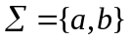that contain equal num number of a’s and b’s. show the computation on i/p string abcb. | CO5 | (10)
 | b) | Discuss the problems that cannot be solved by Turing machine. | CO5 | (04)
 | c) | State and explain post correspondence problem. | CO5 | (06)
10. | a) | Define recursively enumerable language and recursion language. | CO5 | (04)
 | b) | Explain the various programming techniques used in Turing machines. | CO5 | (08)
 | c) | With a diagram, explain the algorithm for blank tape halting problem. | CO5 | (08)

****************

